IEEE TRANSACTIONS ON KNOWLEDGE AND DATA ENGINEERING, VOL. 35, NO. 4, APRIL 2023 3433

An Effective and Efﬁcient Algorithm for K-Means Clustering With New Formulation

Feiping Nie [](https://orcid.org/0000-0002-0871-6519), Ziheng Li [](https://orcid.org/0000-0002-3678-261X), Rong Wang [](https://orcid.org/0000-0001-9240-6726), and Xuelong Li, Fellow, IEEE

Abstract—K-means is one of the most simple and popular clustering algorithms, which implemented as a standard clustering method in most of machine learning researches. The goal of K-means clustering is ﬁndinga set of cluster centers and minimizing the sum of

squared distances between each sample and its nearest clustering center. In this paper, we proposed a novel K-means clustering

algorithm, which reformulate the classical K-Means objective function as atrace maximization problem and then replace it with a new formulation. The proposed algorithm does not need to calculate the cluster centers in each iteration and requires fewer additional

intermediate variables during the optimization process. In addition, we proposed an efﬁcient iterative re-weighted algorithm to solve the involved optimization problem and provided the corresponding convergence analysis. The proposed algorithm keeps a consistent

computational complexity as Lloyd’s algorithm, O(ndk), but shows afaster convergence rate in experiments. Extensive experimental results on real world benchmark datasets show the effectiveness and efﬁciency of the proposed algorithm.

Index Terms—Clustering, K-means, optimization, re-weighted

◆

1 INTRODUCTION

and has a long and rich history in a variety of scientiﬁc ﬁelds such as pattern recognition,machine learning, bioin- formatics and image processing [1], [2], [3], [4]. In spite of the fact that there is a large number of clustering algorithms have been proposed, K-means clustering, as one of the most simple and well-studied clustering algorithms [5], is still been widely used [6], [7]. The goal of K-means clustering is assigning the data set into k clusters such that the sum of the squared distances between each point and its nearest clustering center is minimized. Because of the advantages of simplicity, efﬁciency and stable performance, K-means clustering always be implemented as a standard clustering method in lot of machine learning researches [8], [9].

LUSTERING is a fundamental machine learning problem,

C

K-means clustering aims at ﬁnding k cluster centers, such that the sum of squared distances between all points and the corresponding closest centers is minimized. Unfortunately, it is an NP-hard problem even with just two clusters [10], [11], [12]. Lloyd [13] proposed a local search algorithm for K-means clustering, which becomes one of the most popular



● The authors are with the School of Computer Science, School of Artiﬁcial Intelligence, Optics and Electronics (iOPEN), and the Key Laboratory of Intelligent Interaction and Applications (Ministry of Industry and Infor- mation Technology), Northwestern Polytechnical University, Xi’an, Shaanxi 710072, China. E-mail: {[feipingnie](mailto:feipingnie@gmail.com), [liziheng09](mailto:liziheng09@gmail.com)}@gmail.com, [wangrong07@tsinghua.org.cn](mailto:wangrong07@tsinghua.org.cn), [li@nwpu.edu.cn](mailto:li@nwpu.edu.cn).

Manuscript received 30 Oct. 2020; revised 21 Apr. 2021; accepted 29 Oct. 2021. Date of publication 1 Mar. 2022; date of current version 7 Mar. 2023.

This work was supported in part by the National Key Research and Develop- ment Program of China under Grant 2018AAA0101902, in part by the Natu- ral Science Basic Research Program of Shaanxi under Grant 2021JM-071, in part by the National Natural Science Foundation of China under Grants 61936014 and 61772427, and in part by the Fundamental Research Funds for the Central Universities under Grant G2019KY0501.

(Corresponding author: Feiping Nie.)

Recommended for acceptance by M. Wang.

Digital Object Identiﬁer no. 10.1109/TKDE.2022.3155450

clustering algorithms and has been used in extensive scien- tiﬁc and industrial applications. Lloyd’s algorithm begins with k arbitrary centers, such as k randomly selected sam- ples from the data set. Then, assigns each sample to the nearest center, and updates the k centers by calculating the centers of the new clusters. Repeat the steps of assigning samples and calculating centers until the algorithm con- verges. Lloyd’s algorithm is simple and effective, but it still suffers from several drawbacks. First, Lloyd’s algorithm is a heuristic method. Second, Lloyd’s algorithm is highly sensi- tive to the initialization of the k centers, and it always con- verges to a local minimum and easily gets trapped in poor local solution [14], [15] with a bad initialization. Third, it needs to calculate the distance between each sample and all the centers in each iteration, which will poses new chal- lenges to computation and storage cost.

A variety of algorithms have been developed for these issues. One line of researches focuses on the sensitivity to the initialization of K-means clustering algorithms. K-means clustering algorithm always ﬁnitely converges to a local minimum, and a poor initialization may leads to a bad clus- tering performance and an exponential running time in the worst cases. Lozano etal. [16] conﬁrms that different initiali- zation will affect the performance of K-means clustering algorithm. Therefore, how to choose a better initialization becomes a important issue to a lot of the existing researches [17], [18], [19], [20], [21], [22]. These researches believe that a good initialization can help K-means clustering algorithms to ﬁnd a better solution with less iterations. The simplest strategy of initialization is randomly select a set of samples as cluster centers. However, the performance of the K- means clustering can not be guaranteed due to the uncer- tainty of random selection. Except for random initialization, as widely reported in the literature, the most representation method is the K-means++ method [23]. K-mean++ method uses a seeding strategy that preserves the diversity of seeds while being robust to outliers. Besides, Balanced K-means

1041-4347 © 2022 IEEE. Personal use is permitted, but republication/redistribution requires IEEE permission.

See [https://www.ieee.org/publications/rights/index.html for more information](https://www.ieee.org/publications/rights/index.htmlformoreinformation).

Authorized licensed use limited to: Harbin Institute of Technology. Downloaded on February 28,2025 at 07:01:55 UTC from IEEE Xplore. Restrictions apply.

3434 IEEE TRANSACTIONS ON KNOWLEDGE AND DATA ENGINEERING, VOL. 35, NO. 4, APRIL 2023

based Hierarchical K-means(BKHK) [24] segments the sam- ples into two balanced clusters iteratively, and adopts bal- anced binary tree structure to generates representative cluster centers. It has been widely used in the selection of anchor points in spectral clustering. Based on the effective- ness and efﬁciencyofBKHK, it also can be used to select the initial cluster centers for K-means clustering algorithms with large-scale datasets.

Another line of researches aims to reduce the computa- tional and storage consumption of K-means clustering algo- rithms. Some of them try to reduce the computational consumption by avoiding unnecessary distance calculations oracceleratethis process [25],[26], [27].Reducing unnecessary distance calculation can effectively reduce the calculational consumption caused by samples assignment in each iteration. For instance, Newlinget al. [28] proposed a tight bounds tech- nique, to eliminates further redundant distance calculations. Besides, dimensionality reduction is also commonly used to accelerating the process of K-means clustering [29], [30]. Dimensionality reduction based methods try to accelerate K- means clustering algorithms by reducing the dimension of the data points. In general, dimensionality reduction based meth- ods can be divided into two groups: feature extraction based method and feature selection based method. For feature extraction based method, both singular value decomposition and principal component analysis have been used to prepro- cess the data forK-means clustering algorithms [29], [31]. Fea- ture selection based methods try to construct the lower dimensional space of the datasets with a subset of representa- tion features [32], [33], [34]. In addition, some algorithms use binary coding [35] or data structure [36], [37] to accelerate the k-meansclustering algorithms. For example, Kaushik [38] pro- posed an effective sparsiﬁcation method to speedup the algo- rithm by sparsify the original data matrix.

However, most of the existing works are devoted to accelerating the K-means algorithm and reducing the calcu- lation cost by seeking better initialization conditions or changing the k-means distance calculation strategy. Differ- ent with these works, we focus on the optimization process of K-means clustering algorithm. In this paper, we develop a novel algorithm to solve the K-means clustering problem. Unlike Lloyd’s algorithm, which is a heuristic method, our algorithm has deﬁnite theoretical guarantees. We reformu- lated the classical K-means objective function as a trace maximization problem and then replaced it with a new for- mulation. Compared with the original K-means clustering method, the new objective function does not need to calcu- late the cluster centers and requires fewer additional inter- mediate variables caused by the calculation of cluster centers. In addition, it can be easily optimized with an efﬁ- cient iterative re-weighted method. For summarization, we present the main contributions of this work as follows:

● A novel algorithm is proposed for K-means cluster- ing. We reformulated the objective function of K- means as an equivalent counterpart. The new objec- tive function does not need to calculate the cluster centers and requires fewer additional intermediate variables.

● We develop an effective algorithm to solve the

computational complexity as Lloyd’s algorithm, O(ndk). More importantly, the convergence of our algorithm has a veriﬁable theoretical guarantee and shows afaster convergence rate in experiments.

● Our algorithm retains the advantage as Lloyd’salgo- rithm which can be accelerated by parallel comput- ing. In addition, our algorithm can also be combined with some existing methods for improving perfor- mance or speeding up the algorithm, such as initiali- zation methods and dimensionality reduction based methods.

● Extensive experimental results on a series of real world data sets demonstrate the effectiveness and efﬁciency of the proposed method. Compared with Lloyd’s algorithm, our algorithm performs better and more stable.

The reminder of this work is organized as follows. In Sec- tion 2, we will brieﬂy describe K-means clustering, and then review the related work over it. We provide our approach and corresponding optimization method in Section 3, while in Section 4 we will verify its performance. Finally, a short conclusion and discussion is given in Section 5.

2 RELATED WORK

In this section, we brieﬂy review the prior K-means works. We denote the data matrix as X = [x1 ; x2 ;:::; xn] ∈ Rd ×n, where d is the dimension and n is the number of the sam- ples. xi denotes the i-th column of matrix X, and xij is the

(i;j)-element. Tr(X) is the trace of X, ⅡXⅡ = Tr(XXT )

denotes the squared Frobenius norm of X. We deﬁne F ∈ Rn ×k as indicator matrix, F isa binary matrix with fij = 1 if xi has label yi = j, and the rest elements in the same row of F are 0. Matrices and vectors are represented with bold let- ters in uppercase and lowercase, respectively

2.1 K-Means Clustering

Given a data matrix X ∈ Rd ×n that consists of n samples x1 ; x2 ;:::; xn. K-means clustering problem aims at ﬁnding a partition P = {π1; π2 ;:::; πk } that makes the sum of the square distances between each point and its closest center is minimized. We can formulate the problem as

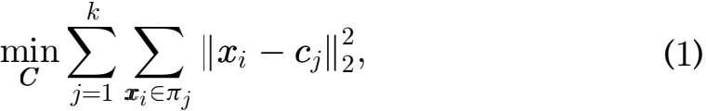

where cj denotes the centroid of cluster πj. Recalling the deﬁnition of squared Frobenius norm and indicator matrix

F. Then, K-means clustering problem can be rewritten as

FC ⅡX - CFT Ⅱ ; (2)

where C = [c1 ; c2 ;:::; ck] ∈ Rd ×k is the centers of the k clus- ters, F is the indicator matrix and F ∈ Rn ×k.

2.2 Lloyd’s K-Means Algorithm

Solving problem (2) exactly is NP-hard. Lloyd [13] proposed a local search algorithm for K-means clustering. It is one of the most popular algorithms and implemented as a standard clustering method in most machine learning researches [17].

involved optimization problem. It has the same Lloyd’s algorithm begins with k randomly centers, the Authorized licensed use limited to: Harbin Institute of Technology. Downloaded on February 28,2025 at 07:01:55 UTC from IEEE Xplore. Restrictions apply.

NIE ETAL.: EFFECTIVE AND EFFICIENTALGORITHM FOR K-MEANS CLUSTERING WITH NEW FORMULATION 3435

centers can be obtained by randomly select k samples from the datasets or randomly assign all the simplestok clusters. Then assign all the samples to the nearest centers and moving the centers to the centroid of the new clusters. Repeat these two steps(assignment and center recom- puted) until convergence. Essentially, Lloyd’s algorithm can be regard as using alternate optimization method to solve problem (2). The entire procedure has been out- lined in Algorithm 1. The objective function value of Eq. (2) decreases monotonically until convergence with the iteration of Algorithm 1.

|  |
| --- |
| Algorithm 1. Lloyd’s K-Means Algorithm |
| Require: data matrix X ∈ Rd ×n, cluster number k. Initialization: k centers selected randomly.  while no converge do  Step 1. Assign each point to the nearest center and update the indicator matrix F inEq. (2);  Step 2. Update matrix C inEq. (2) by moving the k centers to the centroid of the new clusters.  end while |

Lloyd’s algorithm is a heuristic method and sensitive to initialization. There are a lot of existing researches have been proposed to accelerated K-means clustering algorithm, such as initialization methods and dimensionality reduction methods. Both the proposed algorithm and Lloyd’s algo- rithm can be accelerated by these method. Therefore, we will use the two most common initialization method: ran- dom initialization and K-means++ as instance to demon- strate the characteristics of the proposed algorithm.

2.3 K-Means++ Initialization

K-means++ [23] algorithm is one of the most representation initialization method. K-means++ method initializes K- means by choosing random starting centers with speciﬁc probabilities. Deﬁne D(x) as the shortest distance from a data point x to the closet center. K-means++ initialization can be summarized as following step:

● Randomly choose an initial center ci from the dataset X

● Choose another point xi ∈ X as the next center ci

● with probability 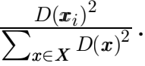

Repeat step 2 until we obtain k centers.

K-means++ method tries to avoid choosing two centers that are too close to each other and generates initial centers near the ﬁnal cluster positions.

2.4 Iterative Re-Weighted Method

In this subsection, we introduce an iterative re-weighted method [39], [40] to solve the involved optimization prob- lem. The re-weighted method can be used to solve the fol- lowing general optimization problem

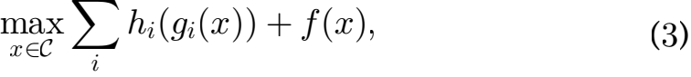

where hi (.) is an arbitrary convex function with respect to

gi (x), and deﬁne h(.) as the sub-gradient of the convex

function hi (.). The overall process of re-weighted method is described in Algorithm 2.

Authorized licensed use limited to: Harbin Institute of Technology. Downloaded on February 28,2025 at 07:01:55 UTC from IEEE Xplore. Restrictions apply.

|  |  |  |
| --- | --- | --- |
| Algorithm 2. Iterative Re-Weighted Method | | |
| while no converge do  Step 1. Calculate the  Di = h (gi (x)) =  ;  Step 2. Update x by | sub-gradient the optimal | of the function: solution to the |
| problem:maxx∈C Σi Tr(Dgi (x)) 十 f(x).  end while | | |

Problem (3) can be converged to a locally optimal solu- tion with Algorithm 2. Iterative re-weighted method can be wide used to solve these non-convex optimization problem like [41], [42], [43].

3 PROPOSED METHOD

In this section, we proposed a novel formulation to solve the K-means clustering problem. We reformulate K-means clus- tering as atrace maximization problem, and rewrite it as an equivalent formulation. Then, we develop an efﬁcient algo- rithm to solve the involved optimization problem. Finally, complexity analysis as well as convergence analysis are given.

3.1 Formulation

Since Ⅱ.Ⅱ is the squared Frobenius norm and ⅡXⅡ =

Tr(XXT ). Then, the K-means clustering problem with Eq. (2) can be reformulated as:

FC Tr((X - CFT )(X - CFT )T ): (4)

Taking the derivative w.r.t.C and setting it to zero, we have:

C = XF(FT F)-1 : (5)

Substituting it into Eq. (4) gives:

min Tr(XXT ) - 2Tr(XFCT )十 Tr(CFT FCT ) F∈Ind

今 min Tr(XXT ) - Tr(XF(FT F)-1FTXT ): (6)

F∈Ind

Since Tr(XXT ) is a constant, Eq. (6) is equivalent to the following problem:

Tr(FTXT XF(FT F)-1): (7)

Then, the K-means clustering problem can be reformu- latedas atrace maximization problem. Here, F is an indica- tor matrix, and there is only one non-zero element in each row of F. Therefore, FT F isa diagonal matrix with the i-th

diagonal element equal toffi, here fi is the i-th column of

matrix F. Problem (7) can be rewritten as:

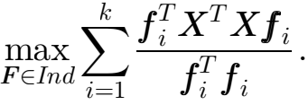 (8)

It is difﬁcult to optimize problem (8) directly. In order to solve the optimization problem, we introduce a variable s, s ∈ R1×k. Then, problem (8) can be reformulated as follow- ing equivalent counterpart.

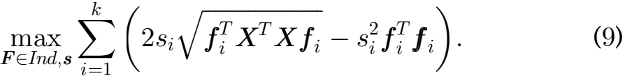

3436 IEEE TRANSACTIONS ON KNOWLEDGE AND DATA ENGINEERING, VOL. 35, NO. 4, APRIL 2023

Lemma 1. Problem (9) is equivalent to problem (8):

Proof. Problem (9) can be solved by updating variables s and F alternately. It is easily to ﬁnd that variable s has close form solution. For each si, taking the derivative w.r. t.s1 and set it to zero, we have:

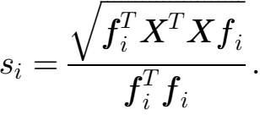 (10)

Substituting Eq. (10) to Eq. (9), then we can easily ﬁnd that problem (9) is equivalent to problem (8). 

From the new objective function Eq. (9),we can ﬁnd that the new formulation proposed in this paper does not need to calculate the cluster centers, it calculates vector s instead of the cluster centers C. In other words, in each iteration, it only needs to update the vector s with k variables instead of calculating the cluster centers with d × k variables. There- fore, the proposed objective function requires fewer addi- tional intermediate variables.

3.2 Optimization

The involved optimization problem can be solved by alter- nate optimization method.

Fixing indicator matrix F, update s: Problem (9) can be rewritten as

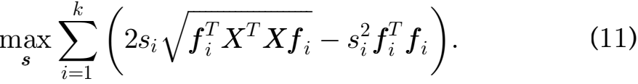

From Eq. (11), we can ﬁnd that the optimization of {s1 ;s2 ;:::;sk } is independent to each other and can be calcu- lated separately. For si, taking the derivative w.r.t.si and set- ting it to zero, we have

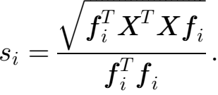 (12)

Fixing s, update indicator matrix F: Problem (9) can be rewrit-

ten as

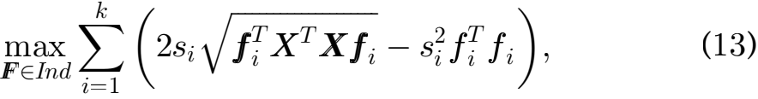

here XT X is a positive semideﬁnite matrix, and √fXTXfi

---------------------

is a convex function w.r.t.fi. Problem (13) can be effectively solved by using the iterative re-weighted method intro- duced in section 2.4.

First, we calculate the sub-gradient of the convex func- tion according to step 1 in Algorithm 2. Here, we deﬁne mi

as the sub-gradient of the convex function √fXTXfi.

---------------------

And the i-th column of matrix M is mi. Then, we have:

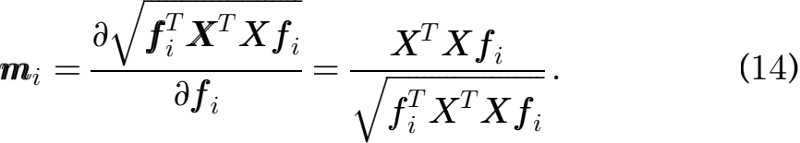

According to the step 2 in Algorithm 2, the indicator

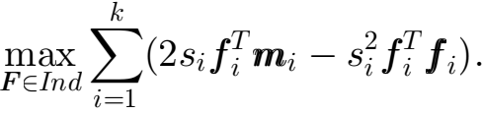 (15)

Since F is an indicator matrix, we can easily ﬁnd that

ffi = f1, (here 1 ∈ Rn ×1 is a vector with all the elements

are 1). Then Eq. (15) can be reformulated as the following trace maximization problem:

max Tr(FT (A — B)); (16)

F∈Ind

~

here, we deﬁnematri~x A = 2MS and matrix B = 1S, A; B ∈ Rn ×k. Matrix S and S ∈ Rk ×k are diagonal matrices, and the i-th diagonal element of~ matrix S is si, while the i-th diago-

nal element of matrix S is s . Besides, 1 ∈ Rn ×k is a matrix

which all the elements are 1. The indicator matrix F has only one nonzero element in each row, and the nonzero ele- ment is 1. Then problem (16) can be solved by ﬁnd the index of the largest element in each row of (A — B). For example, if the l-th element is the largest element in the i-th row of (A — B), then Fil = 1.

Empirical evidences show Algorithm 2 converges very fast and usually converges in 20 iterations [40]. In the subse- quent experiments, we found that the process of updating F with re-weighted method usually converges in a few itera- tions(most of them convergence in 3 ~ 10 iterations).

To sum up, the algorithm we proposed can be summa- rized in Algorithm 3. If the indicator matrix F becomes sta- ble, in other words, if Fnew = Fold or labelnew = labelold, the algorithm converges. It is worth noting that Algorithm 3, like Lloyd’s algorithm, retains the advantage of adopting parallel computation. For example, similar as Lloyd’s algo- rithm, indicator matrix F can be updated row by row independently.

|  |
| --- |
| Algorithm 3. Algorithm to Solve the Problem (9) |
| Require: Data matrix X ∈ Rd ×n, number of clusters k. Initialization: Initial F ∈ Rn ×k.  while no converge do  Step 1. Update s by Eq. (12); while no converge do  Step 2. Update M by Eq. (14);  Step 3. Update F by ﬁnd the index of the maximum value in each row of (A — B), which deﬁned in Eq. (16);  end while end while |

3.3 Empty Clusters Problem

Empty cluster is a common problem to K-means clustering algorithms [44]. Some literatures consider the empty cluster problem as an insigniﬁcant problem and can be solved by executing the algorithm for multiple times. In our algo- rithm, the empty cluster problem may also occur. Our algo- rithm updates the vector s and matrix M by column independently, that is to say, the corresponding fi to the empty cluster i will not affect the variable sj and mj, which related to another cluster. Therefore, as long as the mean- ingless values generated by the empty cluster are removed,

matrix F can be obtained by solving the following problem: the whole algorithm will not be affected.

Authorized licensed use limited to: Harbin Institute of Technology. Downloaded on February 28,2025 at 07:01:55 UTC from IEEE Xplore. Restrictions apply.

NIE ETAL.: EFFECTIVE AND EFFICIENTALGORITHM FOR K-MEANS CLUSTERING WITH NEW FORMULATION 3437

Our algorithm, like other K-means algorithm, can also solve the empty cluster problem through executing the algo- rithm multiple times. However, we prefer to avoid the gen- eration of empty clusters in the optimization process. Therefore, we give the following two strategies as the con- sideration of the empty cluster problem. When updating indicator matrix F in step 3 of algorithm 3, if empty cluster occurs, we can adopt the following processing methods. One of them is we can keep the value of the last iteration for the fi corresponding to the empty cluster i(or choose to keep one non-zero value in fi to avoid the empty cluster problem). Another option is that we can randomly divide the cluster with the largest number of samples into two parts after the occurrence of the empty cluster, and assign one part to the empty cluster fi. These strategies can also be ﬁnd in the other K-means algorithms.

Therefore, according to the speciﬁc situation, we can both choose executing the algorithm multiple times or use the above two strategies to avoid the empty cluster problem.

3.4 Complexity Analysis

Observing the Algorithm 3,we can ﬁnd that the main com- putation cost occurs inStep 1 to Step 3. InStep 1, for the size of fi is n × 1, X is d × n, and F is n × k, the computation complexity of this step is O(ndk). Similarly, we can ﬁnd the computation complexity of step 2 and 3 is O(ndk) and O(nk), respectively. Thus the computation complexity of Algorithm 3 is O(ndk). In addition, the experimental results in section 4 show that the proposed algorithm has a faster convergence rate.

3.5 Convergence Analysis

In this subsection, we will provide the convergence analysis over Algorithm 3. Since step 1 is the optimal solution of problem (11), we can easily prove its convergence. There- fore, the key problem of the convergence analysis of algo- rithm 3 is step2 and step3. And then, we will give the convergence analysis of step2 and step3 in Algorithm 3.

Lemma 2. The step 2 and 3 in Algorithm 3 will decrease the objective value of the problem (13) in each iteration until it converge:

~ ~

Proof. Suppose F and fi is the solution updated by step 3 in Algorithm 3, respectively. According to step 3,we know:

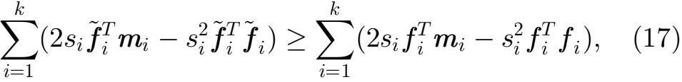

where mi = √X--X--X--f-i- , Eq (17) can be rewritten as

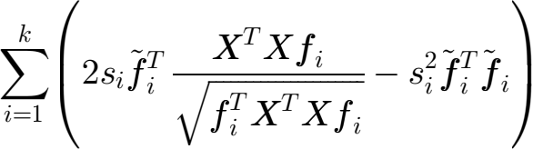

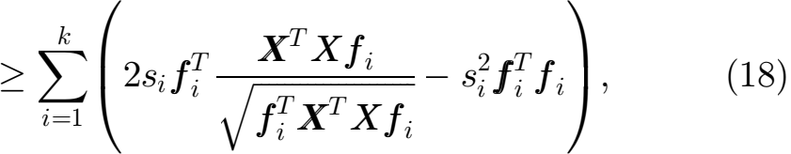

Since √T---f--i- is a convex function w.r.t.fi,

according to the properties of convex function and sub-

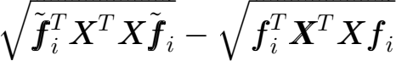

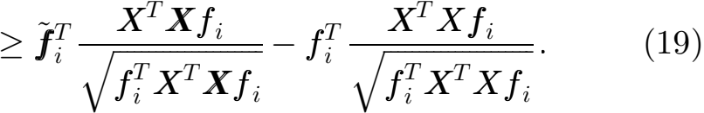

Therefore, we have

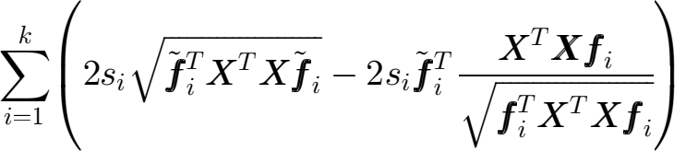

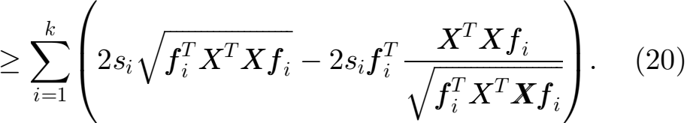

Summing Eqs. (18) and (20) on both side, we arrive at:

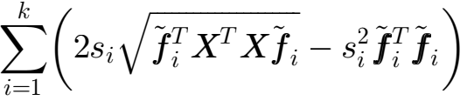

(21)

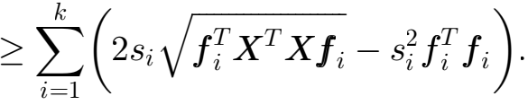

It is worth noting that equality in Eq. (21) holds only when the algorithm converges. Thus the step 2 and 3 in Algorithm 3 will decrease the objective value of the prob- lem (13) in each iteration until it converge. 

4 EXPERIMENTS

In this section, we will compare our algorithm with Llyod’s algorithm. The performance of the proposed algorithm is validated via numerous experiments on real world bench- mark datasets. In order to demonstrate the performance of the proposed algorithm, the experiments can be consist of four parts: the optimal objective function value, clustering performance, convergence analysis and the running time. Considering K-means clustering is sensitive to initialization, random initialization and k-means++ are used in the experi- ments. Both the two algorithms have the same initialization conditions in each experiment, the details of the experi- ments will be described later. All experiments are imple- mented on a DELL Optiplex 7050 with Intel i7-7700 Processor, 32G RAM, and the experimental environment is Matlab 2017a. The code of our algorithm and the datasets used in this paper are provided in [https://github.com/](https://github.com/ZihengLi6321/K-Means-with-new-formulation) [ZihengLi6321/K-Means-with-new-formulation](https://github.com/ZihengLi6321/K-Means-with-new-formulation).

4.1 Data Sets Description

In this paper, a series of real world benchmark datasets are used to evaluate the performance of the algorithms, includes data sets with different dimensions, number of samples, and classes. The property of them is summarized in Table 1, and the data sets are sorted by the dimension of the features.

4.2 Evaluation Metrics

The objective function of our proposed algorithm is an

gradient, we have equivalent counterpart of the classical K-means problem. Authorized licensed use limited to: Harbin Institute of Technology. Downloaded on February 28,2025 at 07:01:55 UTC from IEEE Xplore. Restrictions apply.

3438 IEEE TRANSACTIONS ON KNOWLEDGE AND DATA ENGINEERING, VOL. 35, NO. 4, APRIL 2023

TABLE 1

Description of Datasets

|  |  |  |  |
| --- | --- | --- | --- |
| Datasets | Features | # of Samples | Classes |
| Iris | 4 | 150 | 3 |
| Balance | 4 | 625 | 3 |
| Dermatology | 34 | 366 | 6 |
| uspst | 256 | 2007 | 10 |
| USPSdata_20 | 256 | 1854 | 10 |
| USPSdata | 256 | 9298 | 10 |
| MSRA25 | 256 | 1799 | 12 |
| PalmData25 | 256 | 2000 | 100 |
| Binalpha | 320 | 1404 | 36 |
| Ecoli | 343 | 336 | 8 |
| Corel_5k | 423 | 5000 | 50 |
| MnistData_05 | 784 | 3495 | 10 |
| MnistData_10 | 784 | 6996 | 10 |
| Coil20Data_25 | 1024 | 1440 | 20 |
| Mpeg7 | 6000 | 1400 | 70 |
| TDT2_10 | 36771 | 653 | 10 |

Both the algorithm we proposed and the Lloyd’s algorithm are optimizing problem (2). Therefore, the optimal objective function value1 is used to compare the performance of the two algorithms. In order to ensure the fairness of the experiment, the objective function values of the two algorithms are calculated with Eq. (2)2. In addition, in order to make the experimental results more reliable, we repeat the experiments for multi- ple times and use Min_obj, Max_obj, Mean_obj and Std_obj to present the performance of the two algorithms. A short description over them is as follow:

● Min_obj is the minimum value of the optimal objective function value obtained from multiple experiments.

● Max_obj is the maximum value of the optimal objective function value obtained from multiple experiments.

● Mean_obj is the mean value of the optimal objective function obtained from multiple experiments. Since K-means is sensitive to initialization conditions, the mean value of multiple experimental results can be used to reduce the effects of initialization on the experiment, making the results more credible.

● Std_obj is the standard deviation of the optimal objective function obtained from multiple experi- ments. It reﬂects the degree of dispersion between individuals in the group. Thus, Std_obj can be used to compare the stability of algorithms under differ- ent initialization conditions.

We also present the clustering performance of the pro- posed algorithm. We compared the performance of our algorithm and Lloyd’s algorithm with four widely used evaluation metrics, including ACC(Clustering Accuracy), NMI(Normalized Mutual Information), F-score and ARI (Adjusted Rand Index). In addition, we present the conver- gence curves of the two algorithms, while the number of iterations and the running time are also be considered.

1. The optimal objective function value is the objective function value obtained after the convergence of the algorithm.

2. In the subsequent experiments, our algorithm use Eq. (6) to calcu- late the objective function value. Both theory and experiment can verify that Eqs. (6) and (2) are equivalent.

Similarly, we use Mean_iter, Std_iter, Mean_time and Std_time to denote the mean value, standard deviation of the number of iterations and the running time, respectively.

4.3 K-Means Clustering with Different Initialization In this section, we present the performance of the algorithms by comparing the obtained optimal objective function value. All the optimal objective function values of the two algorithms are calculated with Eq. (2). Since K-means is sensitive to initializa- tion conditions, in the following experiment, both random initialization and K-means++ method are used to demon- strate the performance of the two k-means algorithms.

4.3.1 K-Means Clustering with Random Initialization

Random initialization is the simplest and most common ini- tialization method in k-means clustering algorithms. In this

experiment, we randomly selected k samples as the initial clustering center, and assign all the samples to the neatest cluster as the initial label. To make the results more reliable, we repeated all the experiments 50 times, the initial cluster- ing center was randomly reselected for each time. In addi- tion, both Lloyd’s algorithm and the proposed algorithm have the same initialization condition in each experiment.

We compare the Min_obj, Max_obj, Mean_obj and Std_obj on 17 benchmark datasets in Table 2. From Table 2, we can observe that:

a) According to the experimental results, we can ﬁnd that K-means clustering is sensitive to initialization, especially for some data sets such as iris and derma- tology. It can be seen from the min_obj and Max_obj that the optimal objective function values obtained from multiple experiments are quite different. This is because the K-means algorithms converges ﬁnitely to a local minimum solution, and it easily gets trapped in poor local solution with a poor initializa- tion conditions. However, for some datasets, such as isolet and MnistData_10, initialization conditions have little effect on clustering results, this depends on the structure of the datasets.

b) In terms of the experimental results of min_obj, max_obj and Mean_obj, the performance of our algo- rithm is comparable to that of the Lloyd’s algorithm, or slightly better than that of the Lloyd’s algorithm. Especially for max_obj and Mean_obj, the experi- mental results obtained by the proposed algorithm are better than Lloyd’salgorithm.

c) From the view of std_obj, the proposed algorithm performs better than the Lloyd’s algorithm. The experimental results show that the proposed algo- rithm performs more stable than the Lloyd’s algo- rithm with different initialization.

4.3.2 K-Means Clustering with K-Means++

K-means++ is also one of the most popular initialization methods of K-means clustering. K-means++ choose random starting centers with very speciﬁc probabilities as the initial centers, aims to avoid choosing two centers that close to each other. Similarly, all the experiments are repeated for 50 times, and for each experiment, the initialization for our

Authorized licensed use limited to: Harbin Institute of Technology. Downloaded on February 28,2025 at 07:01:55 UTC from IEEE Xplore. Restrictions apply.

NIE ETAL.: EFFECTIVE AND EFFICIENTALGORITHM FOR K-MEANS CLUSTERING WITH NEW FORMULATION 3439

TABLE 2

K-Means Clustering with Random Initialization

|  |  |  |  |  |  |  |  |  |
| --- | --- | --- | --- | --- | --- | --- | --- | --- |
| Data sets | Llyod’s Algorithm | | | | Our Algorithm | | | |
| Min_obj | Max_obj | Mean_obj | Std_obj | Min_obj | Max_obj | Mean_obj | Std_obj |
| Iris | 7.8941E+01 | 1.4660E+02 | 8.9281E+01 | 2.3931E+01 | 7.8941E+01 | 1.4345E+02 | 8.7915E+01 | 2.2463E+01 |
| Balance | 3.4723E+03 | 3.5968E+03 | 3.4989E+03 | 3.1017E+01 | 3.4723E+03 | 3.5456E+03 | 3.4953E+03 | 2.6274E+01 |
| Dermatology | 5.5809E+03 | 8.1906E+03 | 5.9691E+03 | 5.1806E+02 | 5.5809E+03 | 6.9262E+03 | 5.9312E+03 | 4.0417E+02 |
| uspst | 6.4249E+04 | 6.7019E+04 | 6.4928E+04 | 6.5203E+02 | 6.4246E+04 | 6.6398E+04 | 6.4863E+04 | 5.9359E+02 |
| USPSdata_20 | 6.7330E+04 | 7.0144E+04 | 6.8070E+04 | 7.1188E+02 | 6.7328E+04 | 6.9317E+04 | 6.7864E+04 | 5.0629E+02 |
| USPSdata | 3.3884E+05 | 3.4478E+05 | 3.3971E+05 | 1.7613E+03 | 3.3884E+05 | 3.4254E+05 | 3.3940E+05 | 1.3155E+03 |
| MSRA25 | 1.5515E+08 | 1.7214E+08 | 1.6132E+08 | 4.2495E+06 | 1.5514E+08 | 1.7154E+08 | 1.6125E+08 | 4.0781E+06 |
| PalmData25 | 5.3679E+08 | 5.7811E+08 | 5.6061E+08 | 1.0850E+07 | 5.3613E+08 | 5.7808E+08 | 5.6018E+08 | 1.0698E+07 |
| Binalpha | 6.8557E+04 | 6.9813E+04 | 6.9127E+04 | 3.6068E+02 | 6.8390E+04 | 6.9780E+04 | 6.9060E+04 | 3.2198E+02 |
| Ecoli | 3.4395E+02 | 3.4913E+02 | 3.4589E+02 | 9.9741E-01 | 3.4395E+02 | 3.4906E+02 | 3.4588E+02 | 9.9456E-01 |
| Corel_5k | 4.4700E+06 | 4.5999E+06 | 4.5459E+06 | 3.6060E+04 | 4.4834E+06 | 4.5949E+06 | 4.5420E+06 | 3.4675E+04 |
| MnistData_05 | 8.8648E+09 | 8.9884E+09 | 8.9012E+09 | 3.4075E+07 | 8.8648E+09 | 8.9529E+09 | 8.8944E+09 | 2.7555E+07 |
| MnistData_10 | 1.7826E+10 | 1.7994E+10 | 1.7890E+10 | 4.2997E+07 | 1.7825E+10 | 1.7944E+10 | 1.7868E+10 | 3.1689E+07 |
| Coil20Data_25 | 2.4549E+09 | 2.7534E+09 | 2.5789E+09 | 6.6713E+07 | 2.4910E+09 | 2.7341E+09 | 2.5764E+09 | 6.0914E+07 |
| Mpeg7 | 5.9253E+03 | 6.1652E+03 | 6.0115E+03 | 6.8039E+01 | 5.9266E+03 | 6.1475E+03 | 6.0053E+03 | 6.3751E+01 |
| TDT2_10 | 2.0124E+05 | 2.2267E+05 | 2.0864E+05 | 6.0453E+03 | 2.0085E+05 | 2.2267E+05 | 2.0793E+05 | 5.9844E+03 |

The experiments were repeated for 50 times, the initial clustering center was randomly reselected for each time. The best results are highlighted in bold.

algorithm and the Lloyd’s algorithm is the same. The com- parison of the algorithms across the various data sets is shown in Table 3. From Table 3,we can ﬁnd that:

a) Compared with the experiments with random ini- tialization, the value of min_obj almost unchanged. This is because multiple experiments can effectively alleviate the problem of poor initial conditions caused by random initialization. Thus, random initialization still has the possibility of giving a good initialization, but it is not stable. In contrast, for max_obj and mean_obj, the experiments with K-means++ initiali- zation perform better than that that with random ini- tialization, which is more obviously in some datasets like dermatology and iris. What’s more, the value of std_obj is signiﬁcantly for smaller on most of the data sets. This shows that K-means++ can give better

initialization conditions, so that k-means algorithm has better and more stable performance.

b) Under different initialization conditions, our algo- rithm still performs better than Lloyd’s algorithm. In particular, the upper bound and the mean value of the objective function value obtained in the multiple experiments are smaller than Lloyd’salgorithm.

c) From the view of std_obj, our algorithm is still more stable under different initialization conditions.

From the above K-means clustering experiment under different initialization methods, it can be concluded that our algorithm performs better than Lloyd’s algorithm in a vari- ety of real world data sets. Especially in the upper bound and mean value of the optimal objective function given by our algorithm. At the same time, our algorithm has more stable performance than Lloyd’salgorithm.

TABLE 3

K-Means Clustering with K-Means++ Initialization

|  |  |  |  |  |  |  |  |  |
| --- | --- | --- | --- | --- | --- | --- | --- | --- |
| Data sets | Llyod’s Algorithm | | | | Our Algorithm | | | |
| Min_obj | Max_obj | Mean_obj | Std_obj | Min_obj | Max_obj | Mean_obj | Std_obj |
| Iris | 7.8941E+01 | 1.4345E+02 | 8.5382E+01 | 1.9514E+01 | 7.8941E+01 | 1.4345E+02 | 8.5370E+01 | 1.9478E+01 |
| Balance | 3.4723E+03 | 3.5480E+03 | 3.4886E+03 | 2.0856E+01 | 3.4723E+03 | 3.5472E+03 | 3.4824E+03 | 1.8245E+01 |
| Dermatology | 5.5849E+03 | 7.4933E+03 | 6.0176E+03 | 4.8562E+02 | 5.5847E+03 | 7.0782E+03 | 5.9998E+03 | 4.4545E+02 |
| uspst | 6.4248E+04 | 6.5989E+04 | 6.4842E+04 | 6.0216E+02 | 6.4245E+04 | 6.6430E+04 | 6.4746E+04 | 5.8843E+02 |
| USPSdata_20 | 6.7329E+04 | 6.9668E+04 | 6.7861E+04 | 4.9611E+02 | 6.7334E+04 | 6.9397E+04 | 6.7914E+04 | 4.4843E+02 |
| USPSdata | 3.3884E+05 | 3.4510E+05 | 3.3955E+05 | 1.6975E+03 | 3.3884E+05 | 3.4251E+05 | 3.3903E+05 | 8.2107E+02 |
| MSRA25 | 1.5493E+08 | 1.6992E+08 | 1.5945E+08 | 3.2622E+06 | 1.5409E+08 | 1.6817E+08 | 1.5918E+08 | 3.3812E+06 |
| PalmData25 | 5.3091E+08 | 5.6830E+08 | 5.5112E+08 | 8.8730E+06 | 5.2844E+08 | 5.6830E+08 | 5.5061E+08 | 9.1038E+06 |
| Binalpha | 6.8523E+04 | 6.9758E+04 | 6.9096E+04 | 2.7852E+02 | 6.8319E+04 | 6.9505E+04 | 6.9042E+04 | 2.6517E+02 |
| Ecoli | 3.4302E+02 | 3.4804E+02 | 3.4583E+02 | 9.3771E-01 | 3.4298E+02 | 3.4804E+02 | 3.4582E+02 | 9.3441E-01 |
| Corel_5k | 4.4820E+06 | 4.6506E+06 | 4.5276E+06 | 4.2590E+04 | 4.4827E+06 | 4.6558E+06 | 4.5252E+06 | 3.8850E+04 |
| MnistData_05 | 8.8647E+09 | 8.9871E+09 | 8.9023E+09 | 3.3475E+07 | 8.8644E+09 | 8.9772E+09 | 8.8966E+09 | 3.0252E+07 |
| MnistData_10 | 1.7825E+10 | 1.7996E+10 | 1.7887E+10 | 4.8705E+07 | 1.7825E+10 | 1.7955E+10 | 1.7859E+10 | 4.0644E+07 |
| Coil20Data_25 | 2.4416E+09 | 2.6499E+09 | 2.5498E+09 | 5.7354E+07 | 2.4458E+09 | 2.6423E+09 | 2.5496E+09 | 5.5846E+07 |
| Mpeg7 | 5.8751E+03 | 6.1314E+03 | 5.9962E+03 | 5.9893E+01 | 5.8728E+03 | 6.1246E+03 | 5.9876E+03 | 6.1401E+01 |
| TDT2_10 | 1.9938E+05 | 2.2932E+05 | 2.1123E+05 | 6.3459E+03 | 1.9956E+05 | 2.2172E+05 | 2.1105E+05 | 5.6797E+03 |

All the experiments were repeated for 50 times. The best results are highlighted in bold.

Authorized licensed use limited to: Harbin Institute of Technology. Downloaded on February 28,2025 at 07:01:55 UTC from IEEE Xplore. Restrictions apply.

3440 IEEE TRANSACTIONS ON KNOWLEDGE AND DATA ENGINEERING, VOL. 35, NO. 4, APRIL 2023

TABLE 4

Clustering Results with Random Initialization

|  |  |  |  |  |  |  |  |  |
| --- | --- | --- | --- | --- | --- | --- | --- | --- |
| Data sets | Llyods Algorithm | | | | Our Algorithm | | | |
| ACC | NMI | F-score | ARI | ACC | NMI | F-score | ARI |
| Iris | 0.8407±0.1182 | 0.7103±0.0771 | 0.7896±0.0610 | 0.6769±0.1085 | 0.8570±0.0994 | 0.7213±0.0650 | 0.7982±0.0514 | 0.6921±0.0914 |
| Balance | 0.5147±0.0315 | 0.1078±0.0465 | 0.4616±0.0283 | 0.1346±0.0450 | 0.5246±0.0115 | 0.1078±0.0131 | 0.4635±0.0091 | 0.1369±0.0140 |
| Dermatology | 0.7592±0.1217 | 0.8114±0.0639 | 0.7838±0.0970 | 0.7259±0.1260 | 0.7675±0.1209 | 0.8144±0.0614 | 0.7860±0.0950 | 0.7288±0.1234 |
| uspst | 0.6431±0.0360 | 0.6074±0.0146 | 0.5656±0.0241 | 0.5136±0.0272 | 0.6510±0.0310 | 0.6104±0.0111 | 0.5703±0.0185 | 0.5188±0.0209 |
| USPSdata 20 | 0.6250±0.0312 | 0.6181±0.0155 | 0.5731±0.0210 | 0.5215±0.0237 | 0.6324±0.0334 | 0.6196±0.0164 | 0.5731±0.0224 | 0.5217±0.0254 |
| USPSdata | 0.6513±0.0292 | 0.6075±0.0117 | 0.5766±0.0184 | 0.5255±0.0208 | 0.6590±0.0249 | 0.6101±0.0086 | 0.5812±0.0126 | 0.5308±0.0146 |
| MSRA25 | 0.4903±0.0459 | 0.5739±0.0456 | 0.4047±0.0477 | 0.3411±0.0568 | 0.4943±0.0467 | 0.5752±0.0449 | 0.4062±0.0479 | 0.3429±0.0570 |
| PalmData25 | 0.6884±0.0211 | 0.8906±0.0077 | 0.6480±0.0237 | 0.6442±0.0240 | 0.6888±0.0214 | 0.8908±0.0076 | 0.6484±0.0234 | 0.6446±0.0237 |
| Binalpha | 0.4001±0.0199 | 0.5654±0.0131 | 0.2833±0.0148 | 0.2621±0.0153 | 0.4043±0.0179 | 0.5683±0.0114 | 0.2874±0.0139 | 0.2663±0.0143 |
| Ecoli | 0.5472±0.0724 | 0.4837±0.0421 | 0.5147±0.0695 | 0.3922±0.0761 | 0.5497±0.0739 | 0.4843±0.0403 | 0.5166±0.0690 | 0.3944±0.0754 |
| Corel_5k | 0.1642±0.0051 | 0.2639±0.0035 | 0.0814±0.0024 | 0.0603±0.0024 | 0.1656±0.0044 | 0.2647±0.0026 | 0.0821±0.0020 | 0.0609±0.0020 |
| MnistData_05 | 0.5346±0.0363 | 0.4904±0.0183 | 0.4295±0.0249 | 0.3636±0.0275 | 0.5399±0.0290 | 0.4939±0.0160 | 0.4335±0.0209 | 0.3680±0.0300 |
| MnistData_10 | 0.5346±0.0349 | 0.4897±0.0172 | 0.4307±0.0209 | 0.3648±0.0229 | 0.5412±0.0189 | 0.4915±0.0115 | 0.4341±0.0142 | 0.3685±0.0151 |
| Coil20Data 25 | 0.5768±0.0616 | 0.7360±0.0269 | 0.5566±0.0489 | 0.5299±0.0531 | 0.5800±0.0619 | 0.7364±0.0283 | 0.5570±0.0486 | 0.5304±0.0527 |
| Mpeg7 | 0.4627±0.0176 | 0.6615±0.0113 | 0.2931±0.0219 | 0.2798±0.0228 | 0.4641±0.0162 | 0.6624±0.0109 | 0.2953±0.0218 | 0.2821±0.0227 |
| TDT2_10 | 0.4003±0.0766 | 0.3431±0.0878 | 0.2625±0.0413 | 0.1174±0.0554 | 0.4064±0.0753 | 0.3526±0.0894 | 0.2661±0.0428 | 0.1218±0.0570 |

All the experiments were repeated for 50 times. The best results are highlighted in bold.

4.4 Clustering Performance

The clustering results of the proposed algorithm and Lloyd’s algorithm are presented in Table 4. In this part, we use randomly initialization to obtain the k initial clustering centers. Similar with the previous experiments, we repeated all the experiments 50 times, the initial clustering centers were randomly reselected for each time. In each experiment, the initialization is the same for the two algorithms. The per- formance of the algorithms is measured by ACC, NMI, F- score and ARI in Table 4. From Table 4,we can ﬁnd that the proposed algorithm performs better than Lloyd’salgorithm. However, both algorithms are optimizing problem 1, the performance of the two algorithms are comparable on some of the datasets. Therefore the difference between the two algorithms on these datasets is not signiﬁcant.

4.5 Convergence Analysis

In this subsection, we will analysis the convergence of the two algorithms. In order to demonstrate the convergence of the two algorithms based on different datasets, we selected 4 data sets Binalpha, uspst, Mpeg7 and TDT2_10 from 16 datasets and tested their convergence. In the four data sets, the dimensions of Binalpha and uspst are low, while the dimensions of Mpeg7 and TDT2_10 are relatively high. In contrast, the number of clusters of uspst and TDT2_10 are relatively small, while the cluster number of Binalpha and Mpeg7 are relatively large. At the same time, we use ran- dom and K-means++ initialization methods to initialize the K-means clustering experiments, to present the convergence of the two algorithms. The experimental results are shown in Fig. 1, where (a)-(d) are the cases of random initialization, and (e)-(h) are the cases of initialization with K-means++.

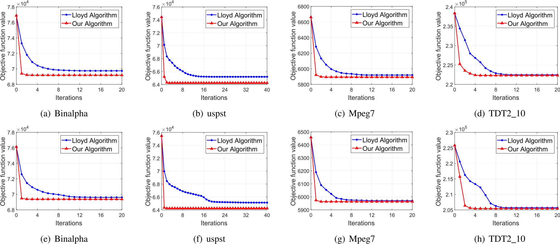

Fig. 1. Convergence curves of the two algorithms on different datasets, where (a)-(d) are the cases of random initialization, while (e)-(h) are the cases of initialization with K-means++.

Authorized licensed use limited to: Harbin Institute of Technology. Downloaded on February 28,2025 at 07:01:55 UTC from IEEE Xplore. Restrictions apply.

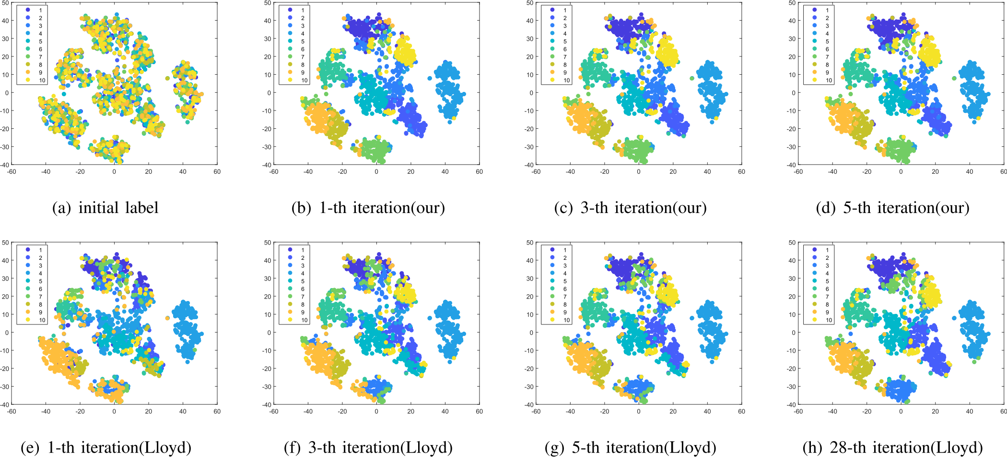

Fig. 2. T-SNE results on uspst dataset. (a) is the result with initial label obtained by random assignment. (b)-(d) is the results obtained by our algo- rithms in different iterations, and our algorithm converges after ﬁve iterations. (e)-(f) is the results obtained by Lloyd’s algorithms in different iterations, and it converges after twenty-eight iterations.

From Fig. 1, we can see that the objective function values of both algorithms decrease monotonously and converge well to a stable local solution. Besides, from Fig. 1, we can see that K-means++ is more likely to provide better initiali- zation conditions than random initialization(Provides a smaller initial objective function value), but there are excep- tions, such as Figs. 1b and 1c. However, regardless of the choice of initialization method, our algorithm shows a faster convergence rate than Lloyd’s algorithm. In addtion, our algorithm can converge to a comparable or even better local solution for different datasets.

In order to demonstrate the performance of our algo- rithm visually, we visualize the clustering results of uspstin different iteration. The clustering results with different iter- ations are presented in Fig. 2. We randomly assigned all samples into k clusters, and Fig. 2a shows the situation after the assignment. Using both algorithms for the clustering task, our algorithm converges after the ﬁfth iteration, while Lloyd’s algorithm converges after the 28th iteration. Figs. 2b, 2c, and 2d present the clustering results obtained by our algorithm in 1-th, 3-th and 5-th iteration respectively, while Figs. 2e, 2f, 2g, and 2h are the clustering results obtained by Lloyd’s algorithm in 1-th, 3-th, 5-th and 28-th iteration. The experimental results show that our algorithm has afaster convergence rate.

4.6 Iterative Times and Running Time

In this subsection, we will present the iterative times and running time of the two algorithms. The performance of the two algorithms are measured by metrics including the num- ber of iteration to convergence and the running time. Both two algorithms can be accelerated by parallel computing. In order to ensure the fairness of the experiments, neither two algorithms use parallel computing in the experiment of

loop through k classes to implement the two steps of sam- ples assignment and center calculation. Besides, we use matrix calculation to calculate the distance between the samples and k clustering centers respectively, assign the samples to the nearest clustering centers, and then updated k clustering centers respectively.

To make the experiment results more reliable, we repeated all the experiments 50 times. The average number of iterations, average time cost and standard deviation were used to measure the performance of the algorithm. The rele- vant experimental results are shown in Tables 5 and 6, where Table 5 is the number of iterations of the two algo- rithms for different data sets, while Table 6 is the running time.

TABLE 5

The Number of Iterations of the Two Algorithms

|  |  |  |  |  |
| --- | --- | --- | --- | --- |
| Data sets | Lloyd’s Algorithm | | Our Algorithm | |
| Mean_iter | Std_iter | Mean_iter | Std_iter |
| Iris | 4.78 | 1.4748 | 3.30 | 0.8631 |
| Balance | 9.92 | 2.3460 | 4.74 | 0.9649 |
| Dermatology | 7.90 | 3.1053 | 3.66 | 1.0224 |
| uspst | 29.38 | 15.0141 | 4.96 | 1.4841 |
| USPSdata_20 | 27.94 | 10.4636 | 4.92 | 1.2428 |
| USPSdata | 59.62 | 19.7700 | 5.96 | 1.3547 |
| MSRA25 | 20.36 | 7.3866 | 5.74 | 1.9981 |
| PalmData25 | 12.68 | 2.5828 | 2.38 | 0.4903 |
| Binalpha | 17.56 | 3.9443 | 5.00 | 1.0498 |
| Ecoli | 4.18 | 1.5345 | 2.76 | 0.8935 |
| Corel_5k | 9.90 | 6.6555 | 6.52 | 4.2197 |
| MnistData_05 | 36.50 | 13.7280 | 9.48 | 2.8374 |
| MnistData_10 | 43.94 | 11.1692 | 11.28 | 3.3869 |
| Coil20Data_25 | 20.92 | 7.8943 | 5.36 | 1.5086 |
| Mpeg7 | 14.10 | 4.1400 | 4.14 | 0.8300 |
| TDT2_10 | 11.68 | 3.4608 | 6.46 | 1.5147 |

comparing the running time, and both algorithms iterated The experiments was repeated for 50 times, in which mean_iter was the aver-

at the same level. Speciﬁcally, for Lloyd’s algorithm, we age number of iterations and std_iter was the standard deviation.

Authorized licensed use limited to: Harbin Institute of Technology. Downloaded on February 28,2025 at 07:01:55 UTC from IEEE Xplore. Restrictions apply.

3442 IEEE TRANSACTIONS ON KNOWLEDGE AND DATA ENGINEERING, VOL. 35, NO. 4, APRIL 2023

TABLE 6

The Running Time of the Two Algorithms

|  |  |  |  |  |
| --- | --- | --- | --- | --- |
| Data sets | Lloyd’s Algorithm | | Our Algorithm | |
| Mean_time | Std_time | Mean_time | Std_time |
| Iris | 0.0029s | 0.0020 | 0.0045s | 0.0021 |
| Balance | 0.0065s | 0.0017 | 0.0493s | 0.0099 |
| Dermatology | 0.0028s | 0.0011 | 0.0040s | 0.0017 |
| uspst | 0.6633s | 0.3381 | 0.2786s | 0.1026 |
| USPSdata_20 | 0.5640s | 0.2064 | 0.2263s | 0.0720 |
| USPSdata | 30.6772s | 10.2156 | 21.9030s | 4.8933 |
| MSRA25 | 0.4868s | 0.1752 | 0.2281s | 0.0741 |
| PalmData25 | 2.5850s | 0.5265 | 0.6007s | 0.1103 |
| Binalpha | 1.1489s | 0.2429 | 0.2469s | 0.0495 |
| Ecoli | 0.0061s | 0.0020 | 0.0035s | 0.0021 |
| Corel_5k | 8.1967s | 5.5001 | 1.4539s | 0.7816 |
| MnistData_05 | 4.7159s | 1.7549 | 1.5411s | 0.4042 |
| MnistData_10 | 50.6742s | 12.8733 | 20.3061s | 5.5228 |
| Coil20Data_25 | 2.6110s | 0.9797 | 0.1975s | 0.0589 |
| Mpeg7 | 5.8161s | 1.6460 | 0.3501s | 0.0533 |
| TDT2_10 | 8.8393s | 2.5683 | 0.0731s | 0.0150 |

The experiments was repeated for 50 times, in which mean_time was the aver- age time and std_time was the standard deviation.

From Table 5, we can observe that our algorithm has a fast convergence rate. Our algorithm always converges after several iterations. More importantly, it can be seen from the std_iter that the convergence rate of our algorithm is very stable, the standard deviation of the number of iterations of multiple experiments is small. Besides, from Table 6 we can easily ﬁnd that, for most data sets, the running time of the proposed algorithm is shorter than that of Lloyd algorithm, while the standard deviation of the running time is still smaller than Lloyd algorithm.

From the above two experiments, it can be seen that our algorithm has a faster convergence rate and requires the same or even shorter running time compared with Lloyd algorithm. In addition, our algorithm is more stable than Lloyd’s algorithm with a smaller standard deviation of mul- tiple experiments on iterative times and running times.

5 CONCLUSION

In this paper, we proposed a novel algorithm for K-means clustering. We reformulated the original objective function of K-means clustering as a trace maximization problem. Then, we replaced the trace maximization problem with an equivalent counterpart. Besides, we utilized the alternate optimization method and iterative re-weighted method to solve the involved optimization problem efﬁciently. Our algorithm has a deﬁnite theoretical guarantee for conver- gence. Compared with Lloyd’s algorithm, our algorithm does not need to calculate the cluster centers in each itera- tion, and requires fewer additional variables caused by cen- ters calculation. A series of experiments on real world benchmark data sets have demonstrated its effectiveness and efﬁciency. It performs effectively and stably in K-means clustering experiments. In addition, the proposed algorithm shows a faster convergence rate in the experiments. How- ever, since the proposed objective function is substantially equivalent to the original objective function of K-means clustering. The performance of clustering with the two algo- rithms on the benchmark datasets is comparable, and the

Authorized licensed use limited to: Harbin Institute of Technology. Downloaded on February 28,2025 at 07:01:55 UTC from IEEE Xplore. Restrictions apply.

difference of the experimental results on some of the data- sets is not signiﬁcant. In the future, we prefer to do more work on how to get a better local solution. The relevant details will be discussed in our future work.

REFERENCES

[1] R. Xu and D. C. Wunsch, “Survey of clustering algorithms,” IEEE Trans. Neural Netw., vol. 16,no. 3,pp. 645–678, May 2005.

[2] J. Wen, Z. Zhang, Z. Zhang, L. Fei, and M. Wang, “Generalized incomplete multiview clustering with ﬂexible locality structure diffusion,” IEEE Trans. Cybern., vol. 51, no. 1, pp. 101–114, Jan. 2021.

[3] M. Wang, W. Fu, X. He, S. Hao, and X. Wu, “A survey on large- scale machine learning,” IEEE Trans. Knowl. Data Eng., early access, Aug. 11, 2020, doi: [10.1109/TKDE.2020.3015777](http://dx.doi.org/10.1109/TKDE.2020.3015777).

[4] M. Wang,W. Fu, S. Hao,H. Liu, and X. Wu, “Learning on big graph: Label inference and regularization with anchor hierarchy,” IEEE Trans. Knowl. Data Eng., vol. 29,no. 5,pp. 1101–1114, May 2017.

[5] A. K. Jain, “Data clustering: 50 years beyond k-means,” Pattern Recognit. Lett., vol. 31,no. 8,pp. 651–666, 2010.

[6] A. Coates and A. Y. Ng, “Learning feature representations with k- means,” in Neural Networks: Tricks of the Trade, Berlin, Germany: Springer, 2012,pp. 561–580.

[7] M. R. Ackermann, M. Mrtens, C. Raupach, K. Swierkot, C. Lam- mersen,and C. Sohler, “Streamkm++ a clustering algorithm for data streams,” J. Exp. Algorithmics (JEA), vol. 17, pp. 2.1–2.30, 2012.

[8] X. Wu et al., “Top 10 algorithms in data mining,” Knowl. Informat. Syst., vol. 14,no. 1,pp. 1–37, 2007.

[9] M. Wang,W. Fu,S. Hao, D. Tao, and X. Wu, “Scalable semi-super- vised learning by efﬁcient anchor graph regularization,” IEEE Trans. Knowl. Data Eng., vol. 28,no. 7,pp. 1864–1877,Jul. 2016.

[10] P. Drineas, A. Frieze, R. Kannan, S. Vempala, and V. Vinay, “Clustering large graphs via the singular value decomposition,” Mach. Learn., vol. 56,no. 1,pp. 9–33, 2004.

[11] M. Mahajan, P. Nimbhorkar, and K. Varadarajan, “The planar k- means problem is np-hard,” in Proc. Int. Workshop Algorithms Com- put., 2009,pp. 274–285.

[12] D. Aloise, A. Deshpande, P. Hansen, and P. Popat, “Np-hardness of euclidean sum-of-squares clustering,” Mach. Learn., vol. 75, no. 2,pp. 245–248, 2009.

[13] S. P. Lloyd, “Least squares quantization in PCM,” IEEE Trans. Inf. Theory, vol. 28,no. 2,pp. 129–137, Mar. 1982.

[14] J. M. Pena,J. A. Lozano, and P. Larranaga, “An empirical compar- ison of four initialization methods for the k-means algorithm,” Pattern Recognit. Lett., vol. 20,no. 10,pp. 1027–1040, 1999.

[15] M. E. Celebi, H. A. Kingravi, and P. A. Vela, “A comparative study of efﬁcient initialization methods for the k-means clustering algorithm,” Expert Syst. Appl., vol. 40,no. 1,pp. 200–210, 2013.

[16] J. M. Pena,J. A. Lozano, and P. Larranaga, “An empirical compar- ison of four initialization methods for the k-means algorithm,” Pattern Recognit. Lett., vol. 20,no. 10,pp. 1027–1040, 1999.

[17] O. Bachem,M. Lucic,S. H. Hassani, and A. Krause, “Approximate k-means++ in sublinear time,” in Proc. 30th AAAI Conf. Artif. Intell., 2016,pp. 1459–1467.

[18] A. Agarwal and A. Saxena, “An accountability of various cluster- ing techniques for improvement of page searching process and analysis,” in Proc. Int. Conf. Sustain. Comput. Sci., 2019,pp. 645–650.

[19] Y. Xu, W. Qu, Z. Li, G. Min, K. Li, and Z. Liu, “Efﬁcient k-means+ + approximation with MapReduce,” IEEE Trans. Parallel Distrib. Syst., vol. 25,no. 12,pp. 3135–3144, Dec. 2014.

[20] W. Zhao, H. Ma, and Q. He, “Parallel k-means clustering based on MapReduce,” in Proc. IEEE Int. Conf. Cloud Comput., 2009, pp. 674–679.

[21] G. Tzortzis and A. Likas, “The minmax k-means clustering algo- rithm,” Pattern Recognit., vol. 47,no. 7,pp. 2505–2516, 2014.

[22] A. Aggarwal, A. Deshpande, andR. Kannan, “Adaptive sampling for k-means clustering,” in Approximation, Randomization, Combinatorial Optimization. Algorithms Techniques, Berlin, Germany: Springer, 2009, pp. 15–28.

[23] D. Arthur and S. Vassilvitskii, “k-means++: The advantages of careful seeding,” in Proc. 18th Annu. ACM-SIAM Symp. Discrete Algorithms, 2006,pp. 1027–1035.

[24] W. Zhu, F. Nie, and X. Li, “Fast spectral clustering with efﬁcient large graph construction,” in Proc. IEEE Int. Conf. Acoust. Speech Signal Process., 2017,pp. 2492–2496.

NIE ETAL.: EFFECTIVE AND EFFICIENTALGORITHM FOR K-MEANS CLUSTERING WITH NEW FORMULATION 3443

[25] Y. Ding, Y. Zhao, X. Shen, M. Musuvathi, and T. Mytkowicz, “Yinyang k-means: A drop-in replacement of the classic k-means with consistent speedup,” in Proc. Int. Conf. on Mach. Learn., 2015, pp. 579–587.

[26] C. Elkan, “Using the triangle inequality to accelerate k-means,” in Proc. 20thInt. Conf. Mach. Learn., 2003,pp. 147–153.

[27] J. Drake and G. Hamerly, “Accelerated k-means with adaptive distance bounds,” Proc. 5th NIPS Workshop Optim. Mach. Learn., vol. 8, 2012.

[28] J. Newling and F. Fleuret, “Fast k-means with accurate bounds,” in Proc. 33rd Int. Conf. Mach. Learn., 2016,pp. 936–944.

[29] M. B. Cohen, S. Elder, C. Musco, C. Musco, and M. Persu, “Dimensionality reduction for k-means clustering and low rank approximation,” in Proc. 47th Annu. ACM Symp. Theory Comput., 2015,pp. 163–172.

[30] G. Hamerly, “Making k-means even faster,” in Proc. SIAM Int. Conf. Data Mining, 2010,pp. 130–140.

[31] Y. Liang, M.-F. Balcan, and V. Kanchanapally, “Distributed PCA and k-means clustering,” Proc. Big Learn. Workshop NIPS, vol. 2013, 2013.

[32] C. Boutsidis, P. Drineas, and M. W. Mahoney, “Unsupervised fea- ture selection for the k-means clustering problem,” in Proc. Adv. Neural Informat. Process. Syst., 2009,pp. 153–161.

[33] M. Cap, A. Prez, and J. A. Lozano, “A cheap feature selection approach for the k-means algorithm,” IEEE Trans. Neural Netw. Learn. Syst., vol. 32,no. 5,pp. 2195–2208, May 2021.

[34] D. Cai, C. Zhang, and X. He, “Unsupervised feature selection for multi-cluster data,” in Proc. 16th ACM SIGKDD Int. Conf. Knowl. Discov. Data Mining, 2010,pp. 333–342.

[35] X. Shen, W. Liu,I. W. Tsang, F. Shen, and Q.-S. Sun, “Compressed k -means for large-scale clustering,” in Proc. 31st AAAI Conf. Artif. Intell., 2017,pp. 2527–2533.

[36] D. Pelleg and A. Moore, “Accelerating exact k-means algorithms with geometric reasoning,” in Proc. 5th ACM SIGKDDInt. Conf. on Knowl. Discov. Data Mining, 1999,pp. 277–281.

[37] T. Kanungo, D. M. Mount, N. S. Netanyahu, C. D. Piatko, R. Sil- verman, and A. Y. Wu, “An efﬁcient k-means clustering algo- rithm: Analysis and implementation,” IEEE Trans. Pattern Anal. Mach. Intell., vol. 24,no. 7,pp. 881–892,Jul. 2002.

[38] K. Sinha, “K-means clustering using random matrix sparsiﬁcation,” in Proc. Int. Conf. Mach. Learn., 2018, pp. 4684–4692.

[39] F. Nie, X. Wang, and H. Huang, “Multiclass capped P-norm SVM for robust classiﬁcations,” in Proc. 31st AAAI Conf. Artif. Intell., 2017,pp. 2415–2421.

[40] F. Nie, J. Yuan, and H. Huang, “Optimal mean robust principal component analysis,” in Proc. Int. Conf. Mach. Learn., 2014, pp. 1062–1070.

[41] R. He, W.-S. Zheng, and B.-G. Hu, “Maximum correntropy crite- rion for robust face recognition,” IEEE Trans. Pattern Anal. Mach. Intell., vol. 33,no. 8,pp. 1561–1576,Aug. 2011.

[42] R. He, W.-S. Zheng, T. Tan, and Z. Sun, “Half-quadratic-based iterative minimization for robust sparse representation,” IEEE Trans. Pattern Anal. Mach. Intell., vol. 36, no. 2, pp. 261–275, Feb. 2014.

[43] X.-T. Yuan and T. Zhang, “Truncated power method for sparse eigenvalue problems,” J. Mach. Learn. Res., vol. 14, no. 4, pp. 899– 925, 2013.

[44] M. K. Pakhira, “A modiﬁed k-means algorithm to avoid empty clusters,” Int. J. Recent Trends Eng., vol. 1,no. 1, 2009, Art. no. 220.



Feiping Nie received the PhD degree in com- puter science from Tsinghua University, China in 2009, and currently is full professor with North- western Polytechnical University, China. His research interests are machine learning and its applications, such as pattern recognition, data mining, computer vision, image processing and information retrieval. He has published more than 100 papers in the following journals and confer- ences: IEEE Transactions on Pattern Analysis and Machine Intelligence, IJCV, TIP, TNNLS,

IEEE Transactions on Knowledge and Data Engineering, ICML, NIPS, KDD, IJCAI, AAAI, ICCV, CVPR, and ACM MM. His papers have been cited more than 20000 times and the H-index is 84. He is now serving as associate editor or PC member for several prestigious journals and con- ferences in the related ﬁelds.

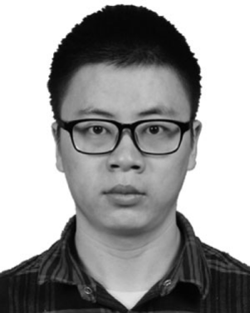

Ziheng Li is currently working toward the PhD degree with Northwestern Polytechnical Univer- sity, Xian, China, under the supervision of Prof. F. Nie. His research interests are machine learning and its applications, including clustering, matrix completion, and information retrieval.



Rong Wang received the PhD degree in com- puter science from Tsinghua University, China in 2009, and currently is full professor with North- western Polytechnical University, China. His research interests are machine learning and its applications, such as pattern recognition, data mining, computer vision, image processing and information retrieval. He has published more than 100 papers in the following journals and confer- ences: IEEE Transactions on Pattern Analysis and Machine Intelligence, IJCV, IEEE Transac-

tionson Image Processing, IEEE Transactions on Neural Networks and Learning Systems, IEEE Transactions on Knowledge and Data Engi- neering, ICML, NIPS, KDD, IJCAI, AAAI, ICCV, CVPR, and ACM MM. His papers have been cited more than 20000 times and the H-index is 84. He is now serving as associate editor or PC member for several prestigious journals and conferences in the related ﬁelds.

Xuelong Li (Fellow, IEEE) is a full professor with the School of Artiﬁcial Intelligence, Optics and Electronics (iOPEN), and the Key Laboratory of Intelligent Interaction and Applications (Ministry of Industry and Informa- tion Technology), Northwestern Polytechnical University, Xian 710119, Shaanxi, China.

" For more information on this or any other computing topic, please visit our Digital Library at www.computer.org/csdl.

Authorized licensed use limited to: Harbin Institute of Technology. Downloaded on February 28,2025 at 07:01:55 UTC from IEEE Xplore. Restrictions apply.